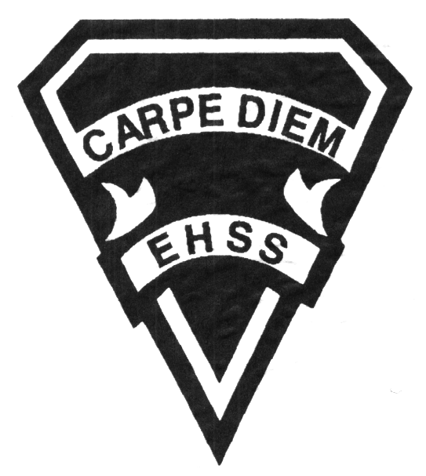

**2019/2020**

### Civics

### (ESL)

**Social Sciences Department**

## Earl Haig

SecondarySchool

# **CHV208**

**Evaluation Profile & Outline**

**Course Description/Rationale/Overview:** This course is designed for students that are new to Canada and are continuing to improve their proficiency in English. The course focuses on the development of language skills and vocabulary while exploring the topics citizenship and government in Canada.

**Class Requirements:** Students should have materials specified by the subject teacher at the beginning of the year.

There is no textbook for this course. A variety of print materials and adapted text are used to explore the topics in this course.

**Assessment and Evaluation Strategies**

Students will also be expected to complete assessment activities of a formative nature in order to learn and to practice the specific expectations that will compose the summative evaluations. Examples of formative assessment may include homework checks, quizzes, peer assessment, presentations, reflection writing, role-play scenarios and observation.

Each unit or strand of the course will be evaluated using summative evaluations. Examples of summative evaluations are tests, case studies, interviews, reports, presentations, seminars, debates, research and other writing assignments.

**Late and/or Missed Evaluation**

##### Late Assignments*

For each assignment, the teacher will inform students of the due date and the ultimate deadline. The ultimate deadline is the last opportunity for students to submit an assignment for evaluation. If an assignment is submitted after the ultimate deadline, it will not be evaluated and a mark of zero will be assigned. In certain circumstances, the student may be granted an extension of the ultimate deadline at the teacher’s discretion, only if an arrangement has been made with the teacher beforehand.

**Missed Tests**

It is the student’s responsibility to make arrangements, ahead of time, for any tests/quizzes that are missed. If a student misses a test/quiz for an unforeseen reason such as illness, the student must bring a note signed by a parent or guardian and be prepared to write the test/quiz immediately upon return to school at a time determined by the teacher. Once the tests/quizzes have been evaluated and returned, students will not be able to make up a missed test - a mark of zero will be assigned.

**Subject-Specific/Department Information**

Teachers in the Social Sciences Department can be reached at (416) 395-3210, ext. 20075 or 20085. Parents wishing to meet with a teacher are requested to make an appointment with the teacher prior to coming to the school.

**Learning Skills\***

**Responsibility** – meets deadlines; takes responsibility for own behaviour

**Organization** – establishes priorities and manages time; uses information, technology and resources top complete tasks time management

**Independent Work** – follows instruction with minimal supervision; uses class time appropriately to complete tasks

**Collaboration** – accepts an equitable share of work in a group; builds healthy peer relationships; works with others to achieve group goals

**Initiative** – looks for opportunities for learning; demonstrates curiosity; approaches new tasks with a positive attitude

**Self-regulation** – sets own goals and monitors own progress; seeks assistance with needed; makes an effort with responding to challenges

###### Final Mark

The final mark for this course will be determined based upon an accumulation of marks from unit summative activities and from a final summative evaluation

**Year’s Work 70%**

This is a culmination of evaluations that have been completed throughout the year. It may include tests, presentations, research, or topic specific assignments.

**Final Summative Evaluation 30%**

This will be completed during the final weeks of the course and will take the form of a reflective activity.

**Achievement Categories and Weighting**

* **Knowledge / Understanding – 25%**

Knowledge of facts and terms; understanding of concepts, principles, guidelines and strategies; understanding of relationships among concepts.

* **Application – 25%**

Synthesizing knowledge and understanding into new and familiar contexts as well as making connections between various contexts.

* **Thinking Inquiry – 25%**

Formulating questions; planning, selecting strategies and resources; analyzing and interpreting information, and forming conclusions.

* **Communication – 25%**

Communication of information and ideas, communication for different audiences, use of various forms of communication.

*From: Ontario Ministry of Education. *Growing Success: Assessment, Evaluation, and Reporting in Ontario Schools*. Toronto: Ministry of Education, 2010, 11.



**2019/2020**

##### Civics

##### (ESL)

**Social Sciences Department**

## Earl Haig

SecondarySchool

# **CHV2O8**

**Evaluation Profile & Outline**

**Course Outline:**

**Unit 1: The Good Citizen**

This unit focuses on the basic ideas and issues that are fundamental to democratic government, to democratic decision making and to democratic citizenship. Students will explore the use of power, needs and wants, conflict resolution and other concepts pertaining to citizenship.

**Unit 2: The Informed Citizen**

This unit focuses on the rights and responsibilities of Canadian Citizenship and the structure of the Canadian system of Government. Students will examine and evaluate the government institutions, political processes, legal safeguards and private and public agencies that help to define democracy in Canada.

**Unit 3: The Active Citizen**

This unit focuses on the democratic methods that may be used by Canadian citizens to make a difference in ensuring that Canada is the type of country Canadians want. Students will examine the ways citizens can bring about change and analyze electoral systems.

**Unit 4: The Global Citizen**

This unit focuses on the critical issues facing the global community and the way to defend and promote the rights and responsibilities of global citizenship. Students will identify issues such as peace, human rights, and environmental citizenship, learn and analyze the roles of the United Nations and Canada in the Global Community.